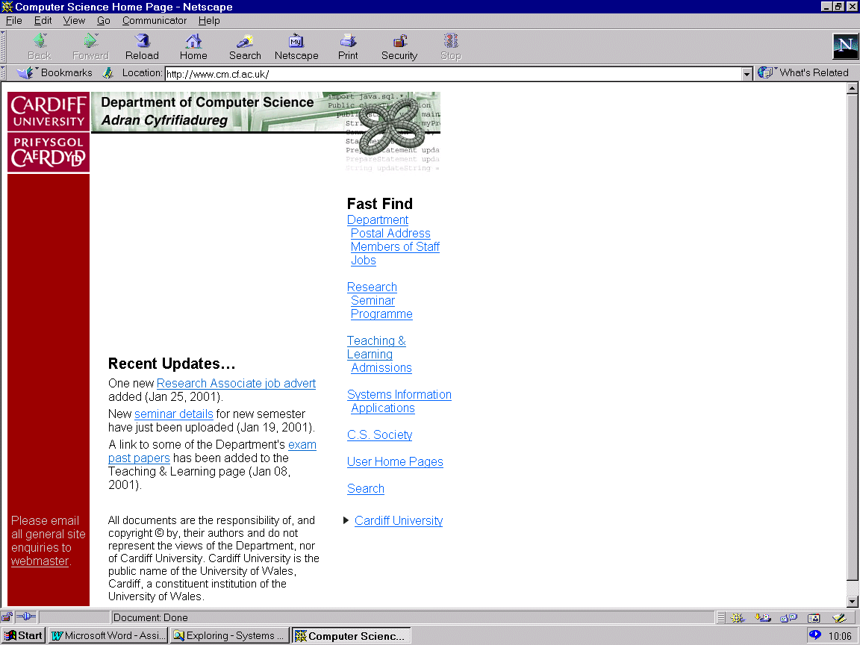CM1202 Developing Quality Software

Lecturer and Module Leader: Helen Phillips

Assignment – Interactive quiz, Design a prototype for use by COMSC during Engagement events

Hand out date: Friday 3rd November 2017

Scenario

Background

Throughout the year the School of Computer Science and Informatics participates in several outreach engagement events organised by the University, College of Physical Sciences and Engineering or COMSC only events. At many of these events we have a stand (table) where we display Raspberry Pi’s and challenge visitors to control a Lego Mindstorm Robot around a ‘Maze’. These activities are received well but realistically it is a one or two person activity and very often the visitors that have a go are the more confirmed ones. We need something additional, a more general activity, what has been suggested is an interactive quiz similar to those you see in museums.

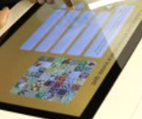
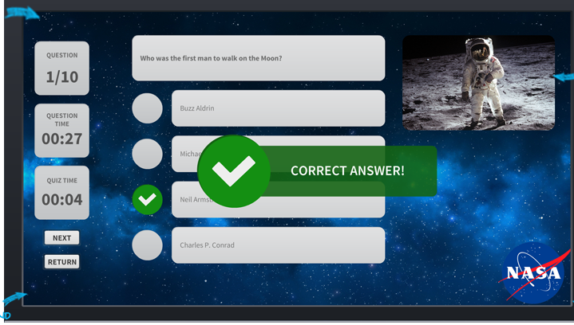

These quizzes are usually multiple choice and challenge visitors to guess the answers to a number of factual questions linked to the display in that area. The visitor will be given feedback after each individual question. Examples of potential posters used can be found attached to this document and in the Assessment folder in learning central.

The engagement events we are involved with normally take place in buildings with restricted access to the internet therefore it should be assumed there will be NO internet access. Also we want the visitors to find / search for the information on posters etc. around the venue rather than going straight to google or Wikipedia.

The Engagement team in COMSC want visitors to be able to do a quiz and to get immediate feedback on their answers. To accommodate busy period in the day, the system should be able to cope with visitors answering only one, a couple or all questions in the quiz. The quiz should be made up of multiple choice questions that incorporates pictorial as well as written questions. The outreach events can be general or specific, for example ‘A Security Day’, or ‘Space’ themes event. The engagement team want individual questions to be linked to a topic or theme, so they can if they wish set the quiz up at the start to ask questions on a particular theme or just general.

Your team has been asked by COMSC to develop a stand-alone package that provides visitors with a multiple choice quiz at Engagement events.

The School of Computer Science & Informatics requires an application that allows people to undertake an interactive quiz. Your prototype should consist of a quiz containing 10 multiple choice questions that can include pictures as well as just words. The quiz should be self-explanatory and simple to use by all. The system should provide immediate feedback after each individual quiz question. It is very important that the quiz can cope with visitors answering just one, some or all the questions. Each visitor must be able to select to quit, restart the quiz and if the visitor completed the entire quiz they should at the end be presented with a summary of their performance. At the start of each event someone from the engagement team should be able to set up the quiz, with the following information, schools attending the event, year groups attending the event. The COMSC engagement team should be ability to add new questions assigning a topic/theme to each and delete or amend current questions.
The Engagement team are also concerned about the security of the solution. As the quiz is run on an isolated machine, no attacks over the network are expected. On the other hand, the Engagement team wants some basic protection against vandalism, e.g. unauthorised persons entering new questions, editing the information about schools attending the event or changing the theme.
The scenario above provides you with the basic requirements however you will be expected to provide some additional features. You can decide on your own additional features, but to help you below are possible additional features, suggested by the COMSC engagement Team:

- The COMSC engagement team would like to be able to obtain statistics about the quiz, for example; percentage of time a question is answered correctly, the question most often answered incorrectly, and percentage of people who gave up at that question.

- The engagement team would also like to be able to collect information about how well pupils from different school or in year group do.

- The questions appear in a random order.

- The COMSC engagement team would like to be able to select the questions to include in the quiz. For example when they are running a ‘Security Day event’ the team would like to be able to select that the questions in the quiz relate to this topic.

You may add any other features that appeal to you, if you so desire! But I recommend that you first discuss this with Helen Phillips the Module Leader who is your client and Head of the COMSC Engagement team.

